**Kitten Adventure Game**

By: Alex Sperry

In Kitten Adventure you play as a person trapped in a maze along with some cats. You are tasked with finding as many cats that you can find and finding the exit to the maze. There are four cats in total to rescue along with an additional mysterious cat? There is also an achievement for rescuing all of the cats from the maze. You can only go through the exit of the maze if you have found at least two cats.

The three variables in my game are cat, dog, and the medal.awardtype. Cat and dog are collected in the game with the amount of cats saved determining on whether or not the player receives the award item at the end of the game.

**UML Diagram**

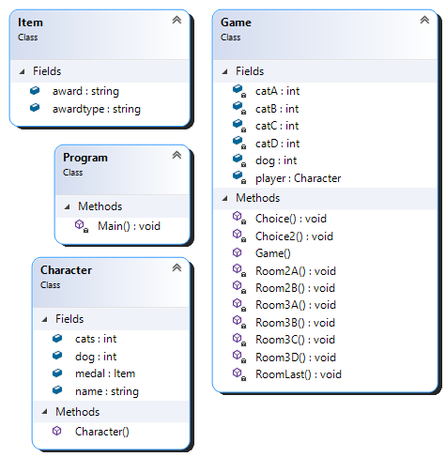

**Inheritance** is displayed in my code with the custom classes (ie. Game class) I made since they inherit from the object class because everything in C# inherits from the base object class.

**Polymorphism** is when a method takes multiple forms, such as in my Character class where the character method has a string form.

**Encapsulation** is present in my Game class with my catA, catB, catC, catD, and dog integers are private and can only be accessed within the Game class so other classes cannot change them.

**Credits**

ASCII text from <http://patorjk.com/software/taag/#p=display&f=Calvin%20S&t=Kitten%20Adventure>

ASCII end game medal from https://ascii.co.uk/art/medal by Joan G Stark

Assistance received from Janell Baxter for helping with an error in my code